Azure devops

1. Go to azure devops

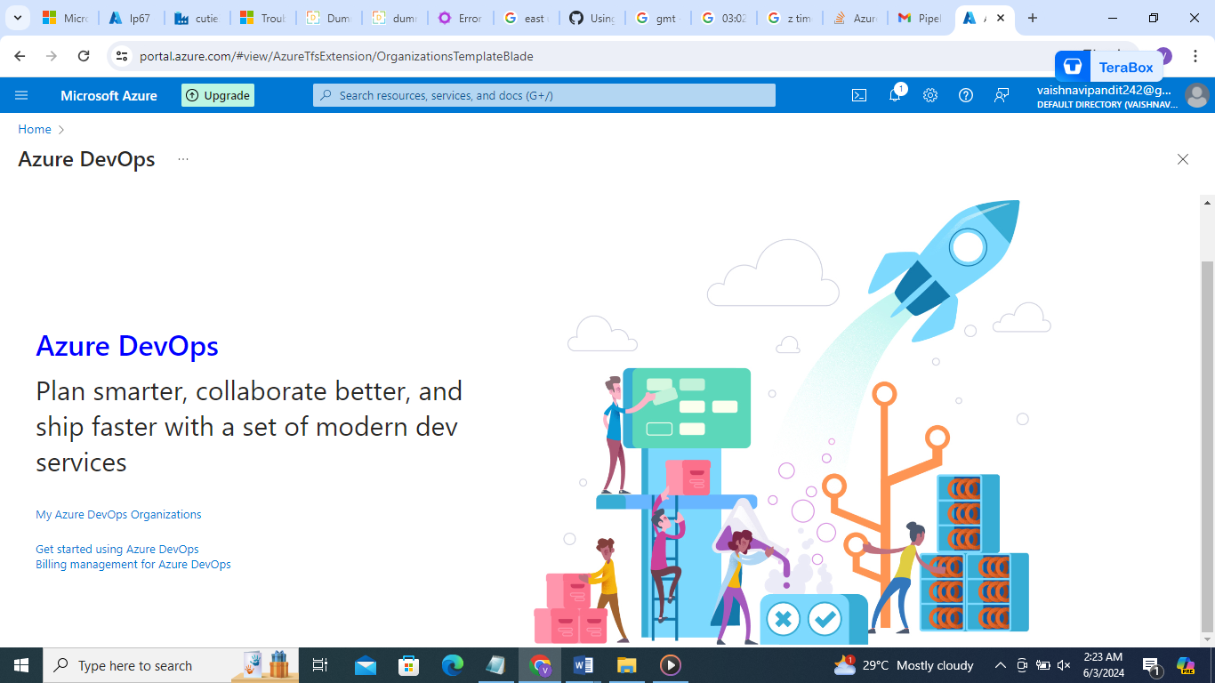

1. My azure devops organization

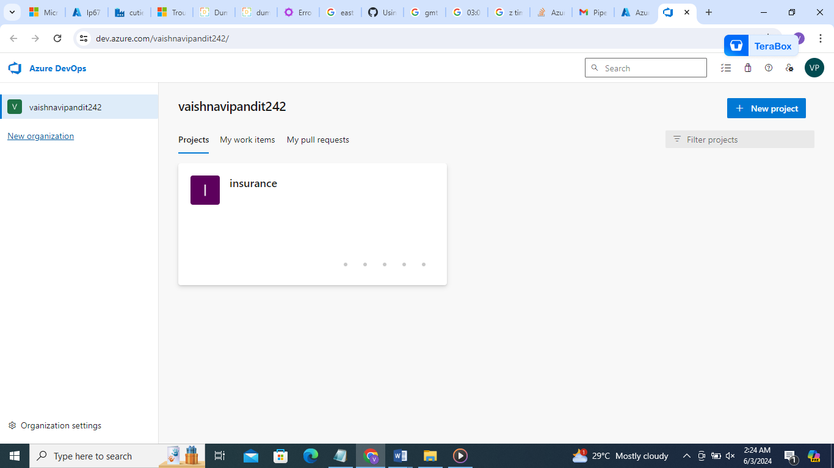

1. Go to project
2. Boards== all the work will be assigned here

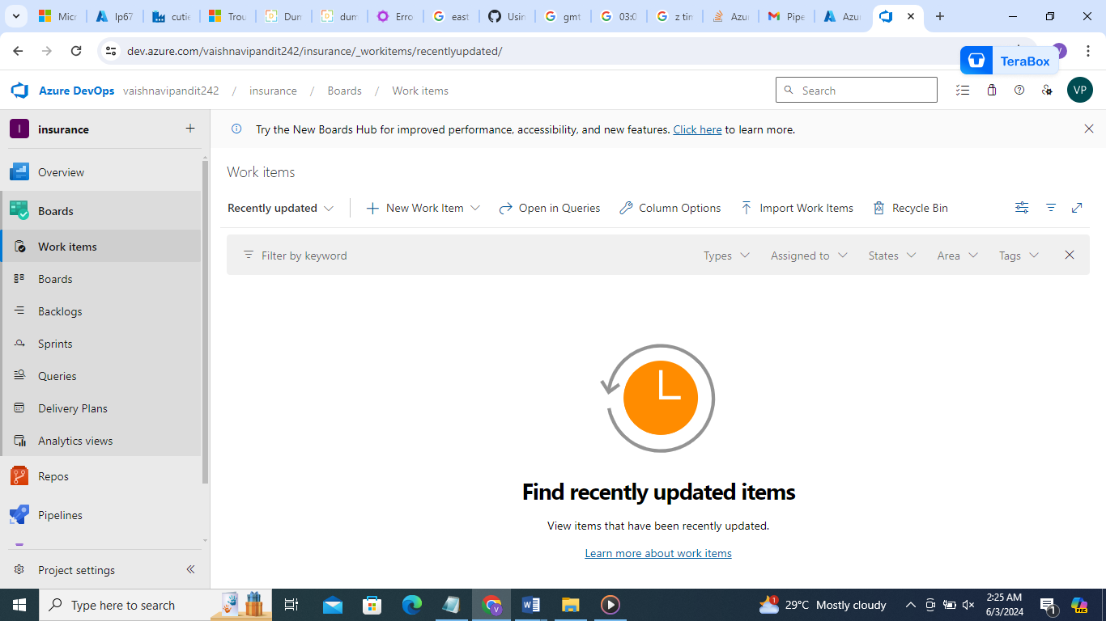

1. Now go to repos

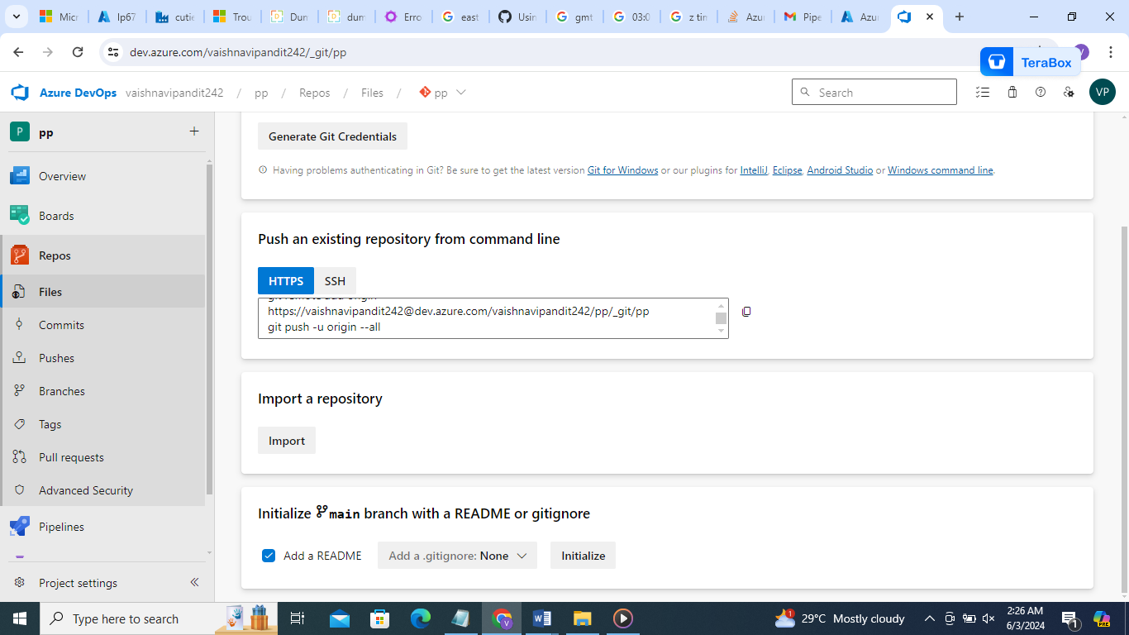

1. Go to initialize

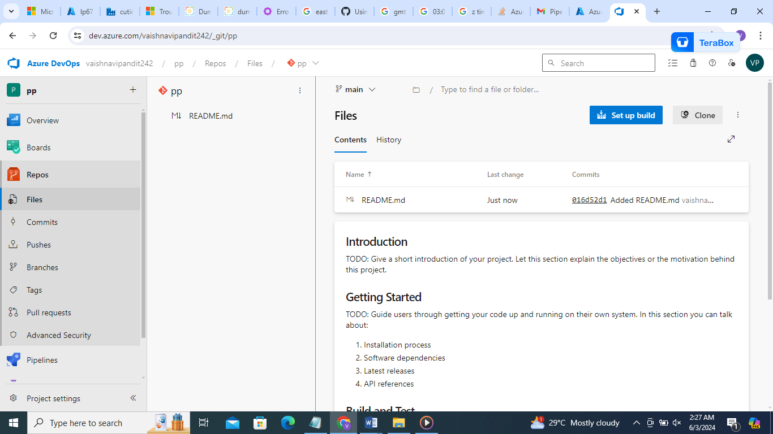

1. Now go to file create new file

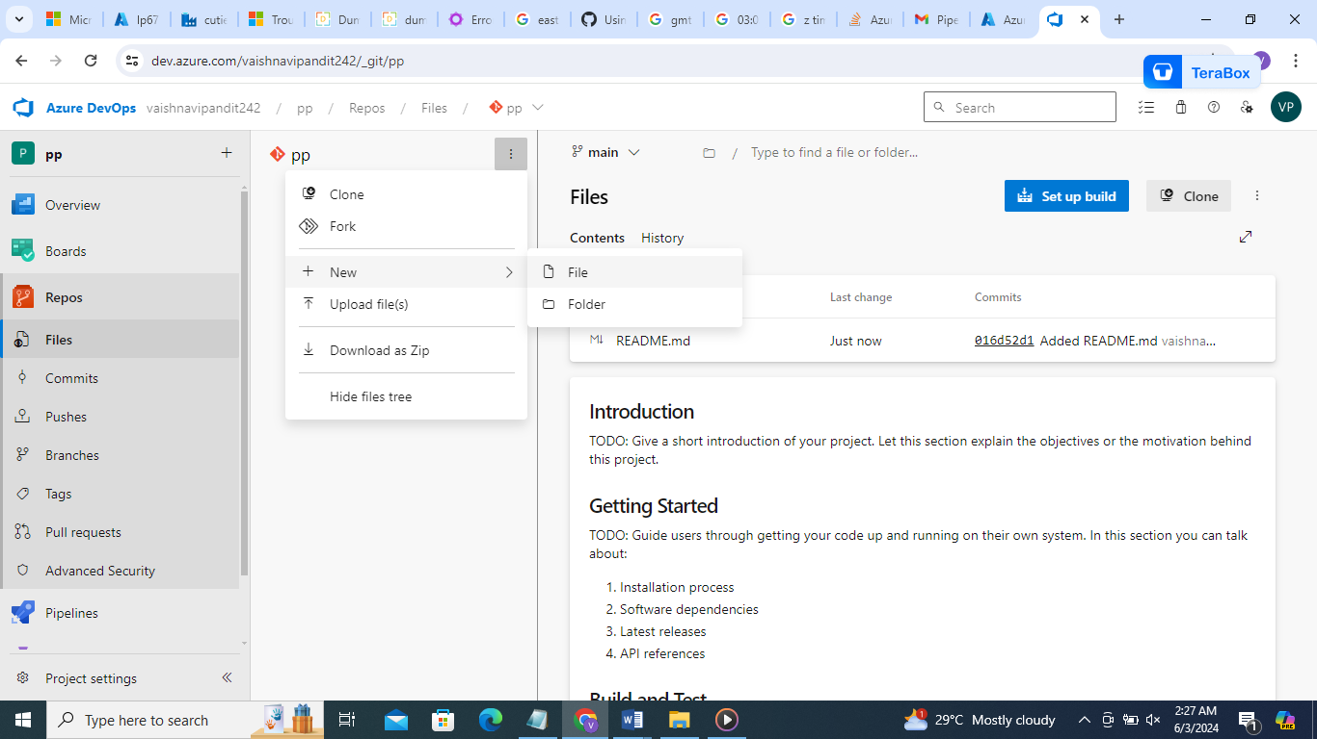

1. Now add text and commit

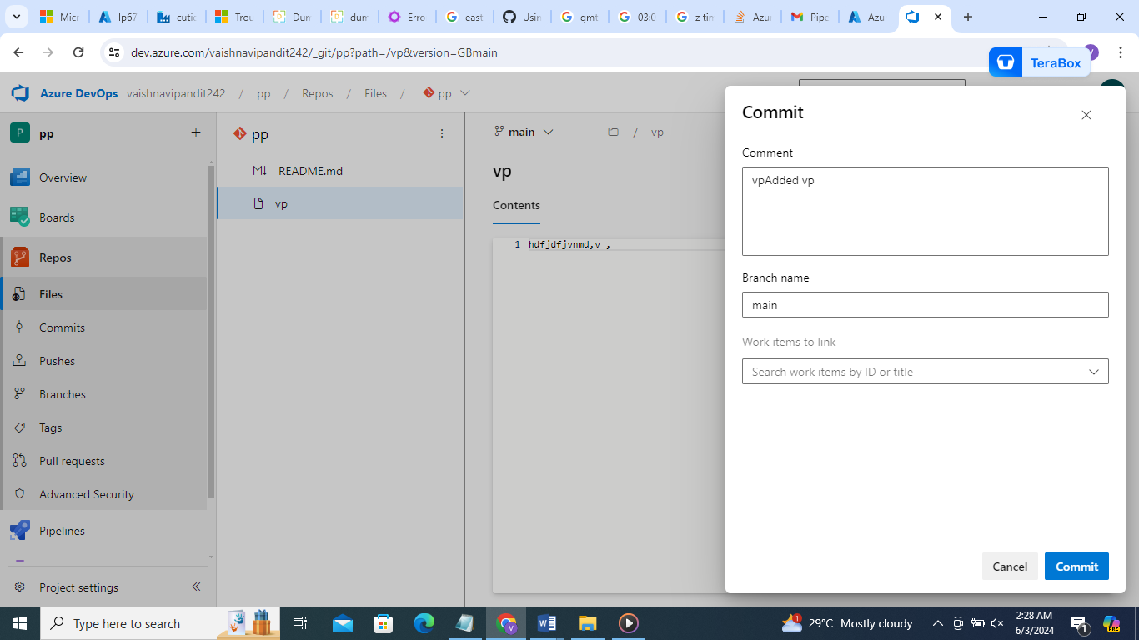

1. Now go to main on top create new branch

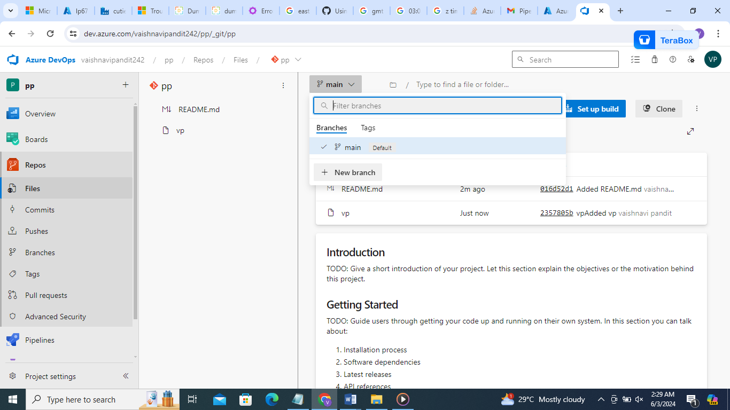

1. 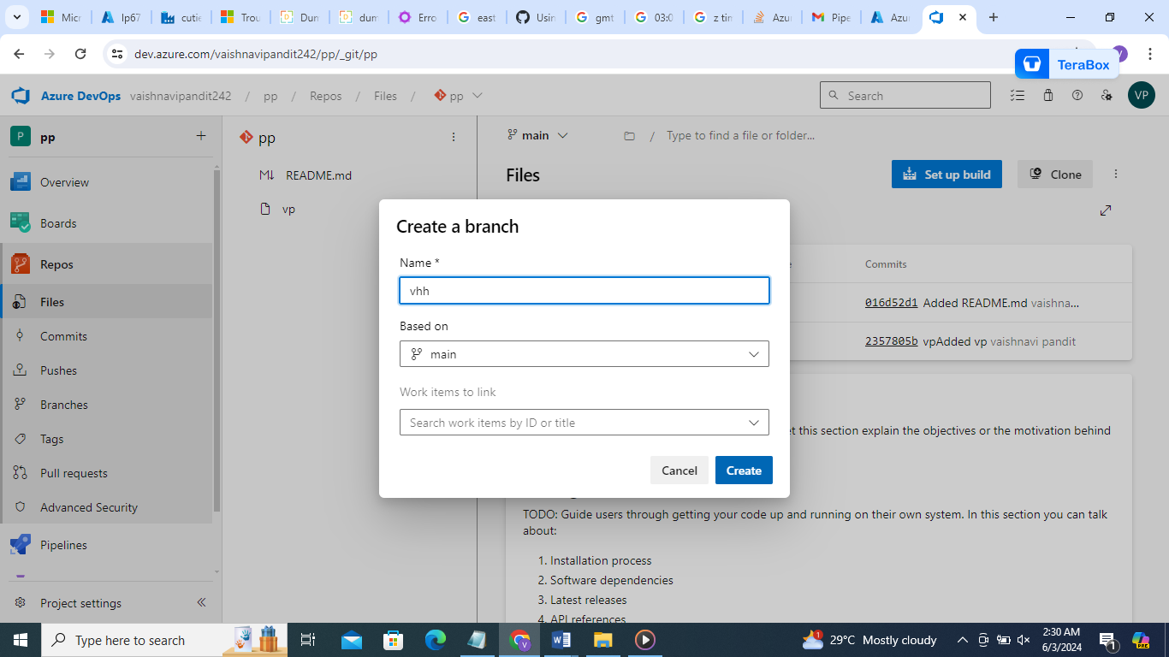
2. Now add new file in your branch

Commit to your branch

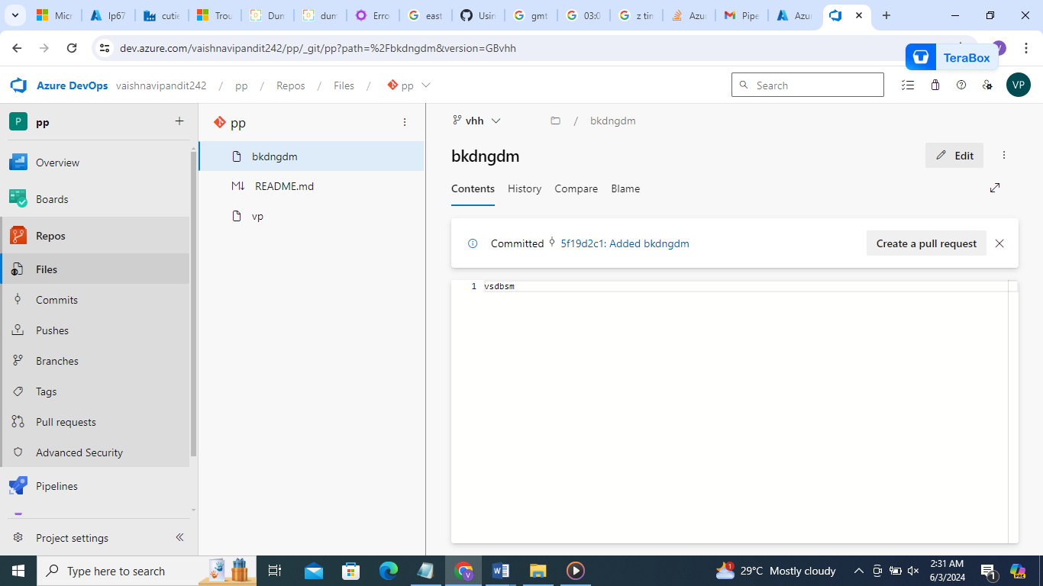

1. Now create pull request and add yourself

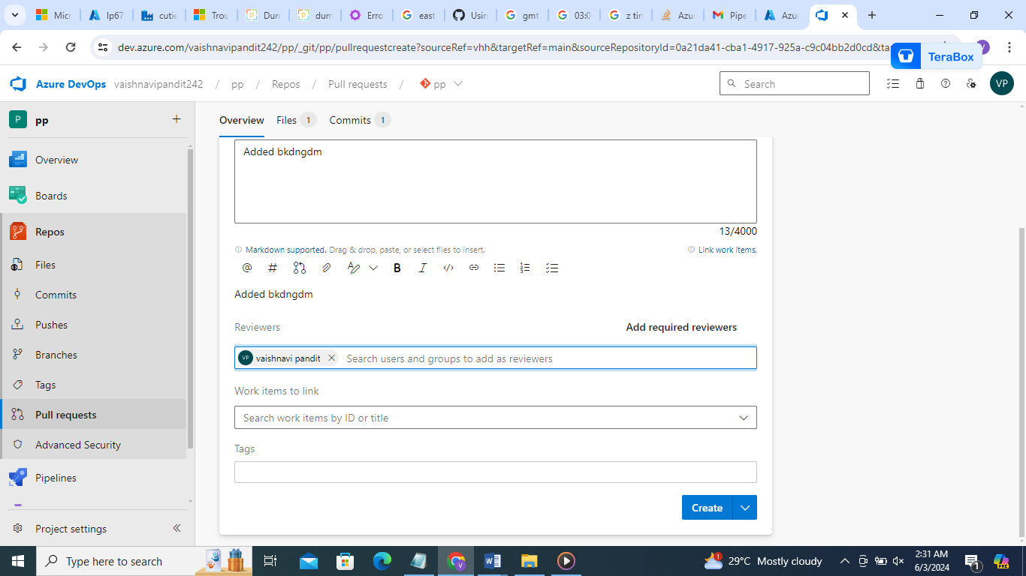

1. Now go to pull requests you will see pull requests accept request

Your code will be in the main branch

Click on approve then complete

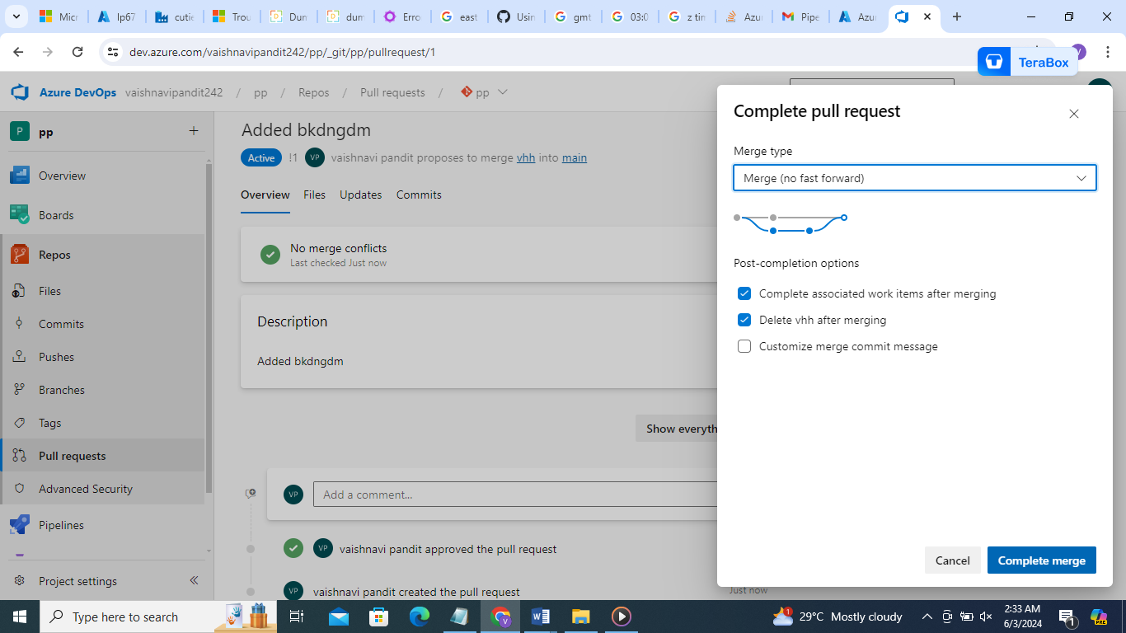

1. 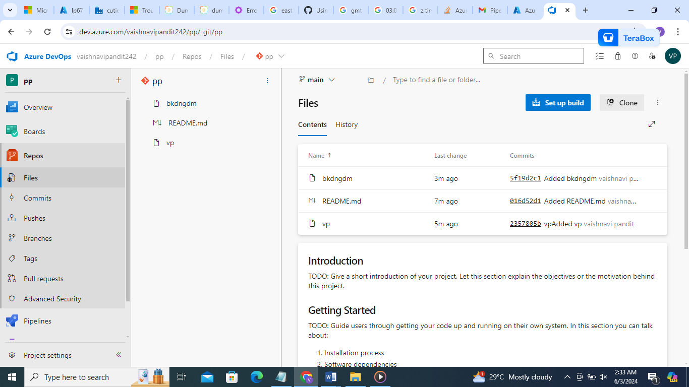
2. Now go to adf manage ->git config

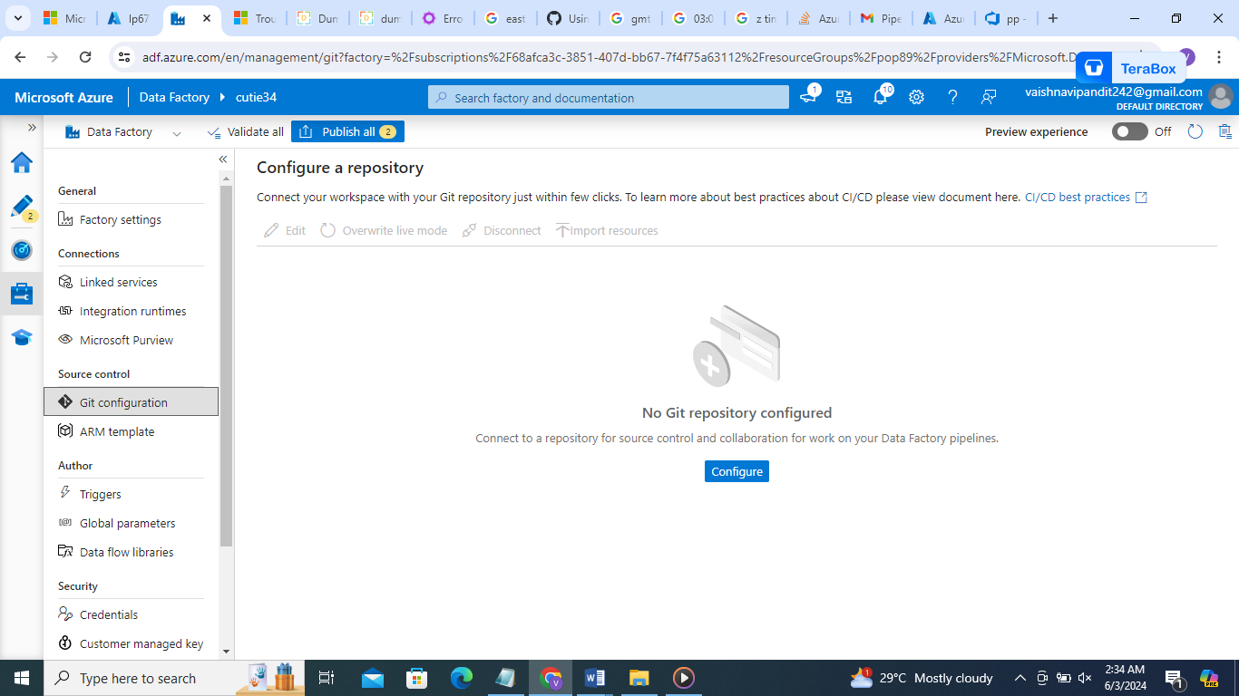

1. Configure->select repo type=azure

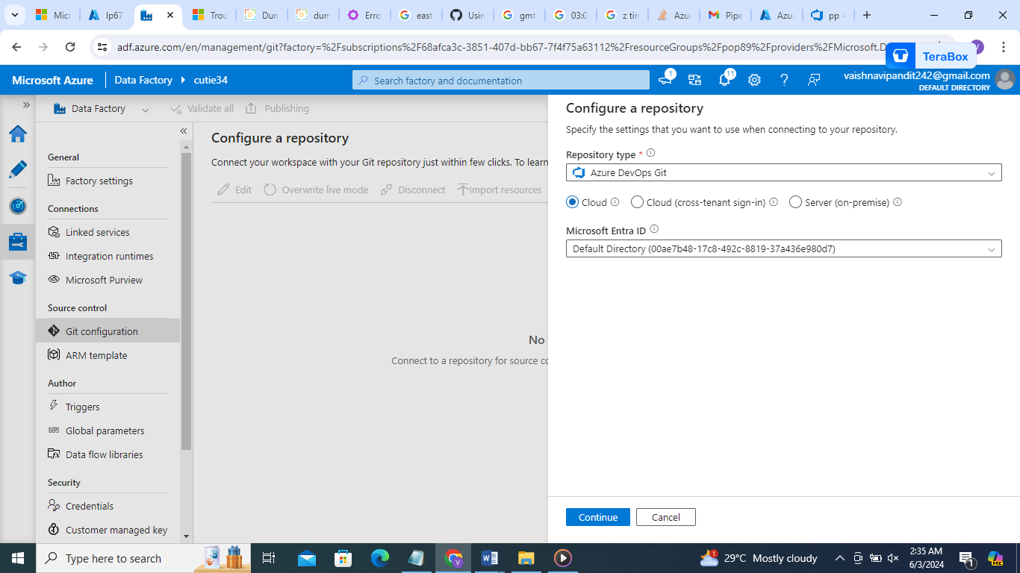

1. Now add your link->for that go to devops ->repos->clone and copy url and paste here

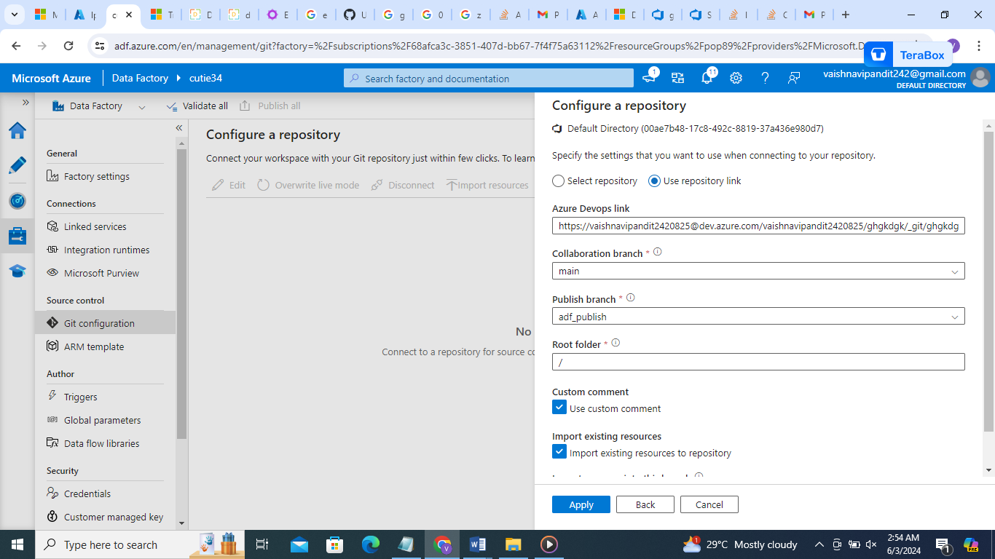

1. Now go to pipelines you will find main on upper side click on new branch

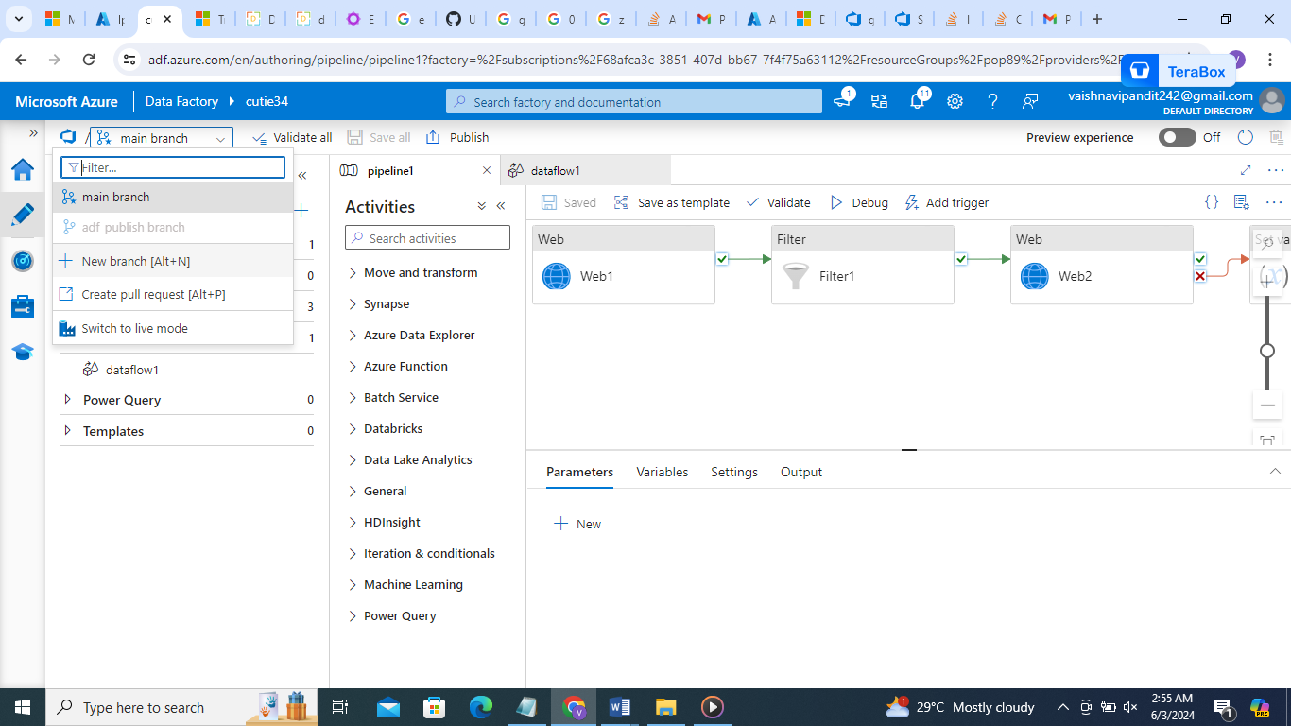

1. Now go to branch create pull request it will diret it to azure devops pull request

